**B2B CABS**  
**A Smart Solution for Cab Business Owners (Vendors)**

### ****About Us****

B2B Cabs is an innovative platform developed by **SKLI INFO TECH**, a reputed software company based in Pondicherry, founded by **Mr. Senthilkumar Ranganathan**. Designed exclusively for cab rental business owners, B2B Cabs connects service providers with a steady flow of bookings at competitive rates, ensuring business growth and profitability.

We take pride in collaborating with the most reliable vendors, carefully selecting professional service providers to deliver exceptional customer experiences. Our services include **exclusive holiday packages, outstation trips, and seamless airport transfers**, making travel effortless and enjoyable for our customers.

Currently, we partner with **30+ trusted vendors across South India**, ensuring hassle-free and high-quality service for our valued customers.

### ****Company Overview****

Formerly known as **Buddies Holidays**, we have been a trusted name in the travel and transport industry since **2013**. Over the years, we have built a strong reputation across **Tamil Nadu, Kerala, Telangana, Karnataka, and Pondicherry**, serving major tourist destinations with **reliable and high-quality transport solutions**.

With a **legacy of trust and excellence**, we have been an esteemed partner of **MakeMyTrip, Yatra, EaseMyTrip, and Goibibo** for over a decade, consistently delivering **seamless and efficient cab rental services**.

Driven by our commitment to **innovation and customer satisfaction**, we have now **expanded our services across Pan India**, providing **business opportunities for cab vendors nationwide**. Our **technology-driven** platform ensures **maximum fleet utilization, transparent pricing, and hassle-free payments**, making us the preferred choice for cab rental businesses.

Our journey of **growth and success** is reflected in our remarkable achievement of a **₹13 crore turnover in the 2023-2024 financial year**, reinforcing our strong market presence and dedication to excellence.

### ****Why Choose B2B Cabs?****

1. **Seamless Booking Management:** Get direct bookings and optimize your fleet usage.
2. **Affordable & Transparent Pricing:** Cost-effective solutions to maximize your profits.
3. **Reliable Partnership:** Over 12 years of trusted collaboration with industry giants.
4. **Technology-Driven Efficiency:** Smart algorithms for optimal ride-matching.

### ****Maximizing Bookings Through Strategic Partnerships****

We ensure a steady flow of bookings for our vendors by leveraging multiple sourcing channels, including **corporate partnerships, online platforms, travel agents, and our proprietary software**. This strategic approach guarantees consistent business growth.

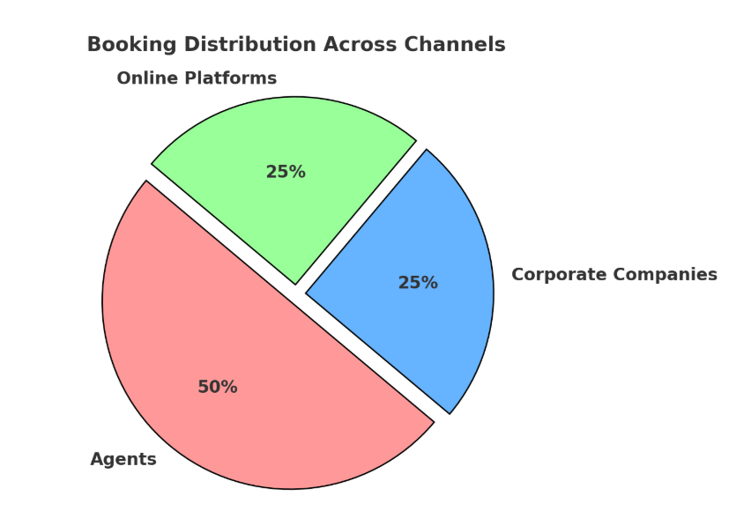

Sample designers creates the pic as per need)

### ****App Features****

#### ****1. Fleet Management - Add Vehicles****

* **Easy Registration:** Vendors can quickly add vehicles via the Add Vehicle menu.
* **Full Control:** Modify or remove listed vehicles anytime.
* **Simple Process:** Enter vehicle details, upload images, and provide registration documents.

#### ****2. Driver Management - Add Drivers****

* **Quick Registration:** Easily add drivers and maintain an up-to-date list.
* **Flexible Availability:** Activate or deactivate drivers as needed.
* **Secure On boarding:** Provide essential details for verification.

#### ****3. Billing & Payments - Add Bills****

* **Hassle-Free Billing:** Generate and manage trip invoices efficiently.
* **Streamlined Payments:** Initiate and track payments seamlessly.
* **Organized Financial Management:** Keep a structured record of trips and earnings.
* **Fast Payments:** Vendors receive payments within **24 working hours**.

#### ****4. Smart Trip Assignment - Vehicle Allotment****

* **Automated Trip Assignment:** Notifications for allotted trips.
* **Manage Pending Trips:** Assign vehicles and drivers with ease.
* **Booking Overview:** Track all active bookings and trip statuses.
* **Comprehensive Booking History:** Access detailed trip records.

#### ****5. Financial Tracking - Payment Reports****

* **Complete Payment Management:** View paid, unpaid, and total bills in one place.
* **Smart Filters:** Advanced search options for efficient tracking.
* **Clear Financial Overview:** Easily monitor earnings and pending payments.

#### ****6. Business & Bank Details - Profile Management****

* **Business Details:** Store and update company information.
* **Bank Account Management:** Securely handle transaction details.
* **Easy Updates:** Modify profile information anytime.

### ****Benefits for Vendors Using the B2B Cabs Application****

1. **Increased Bookings & Revenue**

* Get direct bookings from multiple sources, including agents, corporate clients, and online platforms.
* Maximize fleet utilization with a steady stream of ride requests.

1. **Quick & Hassle-Free Payments**

* Receive payments within **24 working hours** for completed trips.
* Transparent billing system for accurate earnings tracking.

1. **Efficient Fleet & Driver Management**

* Easily add, edit, or remove vehicles and drivers from your dashboard.
* Activate/deactivate drivers based on availability.
* Keep track of vehicle details, licenses, and registration certificates.

1. **Seamless Trip Assignment & Management**

* Automated trip allotment for efficient ride distribution.
* Track active bookings and monitor trip statuses in real time.
* Quickly assign unallotted trips to available vehicles.

1. **Transparent Pricing & Cost-Effective Solution**

* Competitive and **fair pricing model** that benefits vendors.
* No hidden charges, ensuring profitable operations.

1. **Smart Financial & Payment Tracking**

* Monitor all **paid and unpaid bills** from a single dashboard.
* Get a detailed financial breakdown for better business insights.
* Advanced search filters for easy tracking of transactions.

1. **Strong Business Partnerships & Market Expansion**

* Benefit from **12+ years of trusted collaboration** with MakeMyTrip, Yatra, Goibibo, and EaseMyTrip.
* Expand your customer base across Tamil Nadu, Kerala, Telangana, Karnataka, and Pondicherry.

1. **Secure & Convenient Profile Management**

* Store and update company details, contact information, and bank details securely.
* Modify business records anytime for seamless transactions.

1. **Technology-Driven Efficiency**

* AI-powered algorithms match the right cabs with the right rides.
* Automated processes reduce manual effort and increase operational efficiency.

### ****Join B2B Cabs Today!****

Boost your cab rental business with **efficiency, transparency, and profitability** like never before.

**Contact Us:**  
(For contact details need to ask md )